AM000-Asia-China-TLV-Four Boss-Rectangle-Animals of the Four Directions

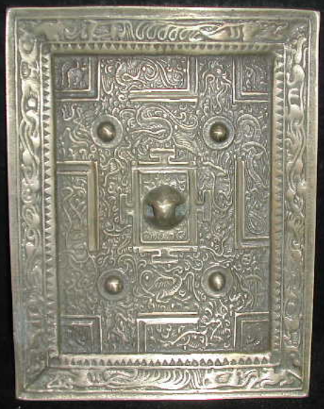

length: 17.00cm  
Width: 13.00cm   
Thickness:1.00cm  
Weight: 0.8 kg

